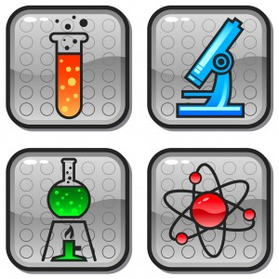  Date  Focus Group  Topic: Doctoral Mentoring in STEM Disciplines  Seeking Doctoral STEM Students who have completed at least two semesters of study to discuss the nature and quality of doctoral mentoring  Sponsored by the National Science Foundation | Study on Mentoring  ────  Seeking Ph.D. Students in STEM disciplines  ────  To participate in a Focus Group  ────  Refreshments and $25 Gift Card  ────  For more information contact:  Lisa R. Merriweather, PhD  lmerriwe@uncc.edu  Dates and Times

