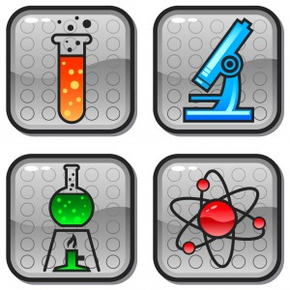  Date  Research Study  Topic: Doctoral Mentoring in STEM Disciplines  Seeking URM Doctoral STEM Students who have completed at least two semesters of study to discuss the nature and quality of doctoral mentoring  Sponsored by the National Science Foundation | Study on Mentoring  ────  Seeking Underrepresented Racial Minorities earning a Ph.D. in a STEM discipline  ────  To participate in a research interview  ────  $25 Gift Card  ────  For more information contact:  Lisa R. Merriweather, PhD  lmerriwe@uncc.edu  Dates and Times

