Textile Engineering, Chemistry and Science Internal REU Program

Introduction and Program Participation

In 2021, the Textile Engineering, Chemistry and Science (TECS) department established an internal summer half-time REU program that is internally funded through student fees, gift money, and support from eight chaired faculty. Undergraduate students of any TECS major, which includes Polymer and Color Chemistry (PCC), Textile Engineering (TE), and Textile Technology (TT), are eligible to apply for the internal REU program. From Tables 1 and 2, our internal STEM REU program has had over 30% of students of color and 58.7% of female participants over the three years.

Table 1: Race Demographics of Internal REU Program over the Past Three Years.

Race | 2021 | 2022 | 2023 | Grand Total
Asian | 4 (14.3%) | 3 (12.5%) | 9 (23.7%) | 16 (17.8%)
Students of Color | 5 (17.9%) | 11 (45.9%) | 12 (31.6%) | 28 (31.2%)
White | 19 (67.9%) | 10 (41.7%) | 17 (44.8%) | 46 (51.2%)
Total | 28 (100%) | 24 (100%)* | 38 (100%)* | 90 (100%)
*- In 2022 and 2023, we included two self-funded students from a sister institution in France. Also, in 2023, we received a very small matching recruitment grant from Eastman Chemical Company to recruit four external applicants from HBCUs to participate with our internal students.

Table 2: Internal REU Gender Demographics of Participants.

Gender | 2021 | 2022 | 2023 | Total
Female | 15 (53.6%) | 12 (50%) | 26 (68.5%) | 53 (58.9%)
Male | 13 (46.5%) | 12 (50%) | 12 (31.6%) | 37 (41.2%)

Program Goals

The goal is to provide opportunities for students who need to take summer school to stay on track, provide experiential learning opportunities for all students, diversify and increase our graduate programs, and help our faculty and Ph.D. students further their research. George et al. (2016) highlighted that internal REU programs offer the advantage of increased student-faculty interactions, fostering student confidence, and providing a long-term ally/mentor. They also can provide the students with supplemental opportunities throughout the academic year, including continuing research. Although traditional REU programs target students in their junior and senior years, it is essential to provide research experiences to undergraduate students at all levels (i.e., freshman through senior). For juniors and seniors, the aim is to impact their immediate decisions regarding graduate school and pursuing advanced degrees. For first- and second-year students, there is an opportunity to inspire them to pursue research early in their academic careers and help guide their academic and career decisions. Regardless, these experiences can assist students when applying for internships and permanent jobs by providing discussion points during interviewing.

Progression to Graduate School

In the last three years of hosting our internal TECS REU program, 53% of students who completed the program are attending graduate school. According to the 2022 end-of-summer survey results, where respondents were questioned about their experiences and thoughts on graduate school, Figure 1 shows that 75% of the 14 participants contemplated pursuing graduate studies upon graduation. Following their participation in the 2021 TECS REU Program, three students who had not previously considered graduate school applied and were accepted to one of the graduate programs available in our department.

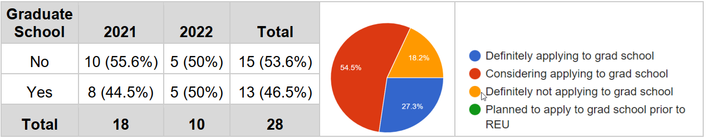Figure 1: Percentage of Internal REU program participants who went to graduate school.

More Information

The TECS Research Experience for Undergraduates website https://sites.textiles.ncsu.edu/tecs-reu/ contains details about expectations for student participants, workshop topics, the schedule of activities, and research conducted by students in previous summers.

References
George, S., von der Embse, N., & Domire,, Z. (2016). Targeted Recruiting and Home Institution Mentor Model for REU Sites (Paper ID #16913). ASEE 2016 (Conference Proceedings. https://monolith.asee.org/public/conferences/64/papers/16913/view)

